# ATM Simulation - Project Report

## Group Members

Ali Hussain – 24K-0578  
Huzaifa Shahid – 24K-0860  
Ammar Mufti – 24K-0586

## Submission Date

20/04/2025

## 1. Executive Summary

This project is a real-life simulation of an ATM system developed using Object-Oriented Programming (OOP) principles in C++. It features a user-friendly graphical interface built with wxWidgets, making it an ideal choice for beginner-friendly GUI development.

The system allows users to perform essential banking operations such as login, PIN verification, cash withdrawal, and transaction history viewing. All user transactions are recorded and stored in a CSV file, ensuring traceability and data persistence.

To extend the functionality beyond C++, a Python script is integrated to perform data analysis and visualization on the recorded transactions using Pandas, Matplotlib, and Seaborn. This provides insights into user behavior and transaction trends.

The overall structure is inspired by real-world banking systems, particularly Bank Al Habib, and reflects a simplified version of how modern ATMs operate. This project not only demonstrates practical application of OOP but also shows how C++ and Python can be combined to build powerful and insightful software systems.

## 2. Introduction

The purpose behind creating this project was to practically implement the concepts taught in our course by applying them to a real-world application. As data science continues to grow rapidly, we decided to enhance our system by integrating data analysis capabilities.

For this, we chose Python, a language widely recognized for its powerful and beginner-friendly tools in the field of data science. By incorporating Python for analytics and C++ for core system logic and GUI, we aimed to demonstrate the use of multi-language integration, which not only makes the system more professional and scalable but also reflects how modern software systems are developed in the industry.

This project allowed us to bridge the gap between theory and practical use while also exploring how traditional programming (C++) can work hand-in-hand with data-driven approaches (Python) to create comprehensive and intelligent applications.

## 3. Project Description

The project encompasses the following key components and functionalities, combining C++ and Python to simulate a real-life ATM system with data analytics support:

● Graphical User Interface (GUI)

A user-friendly and interactive ATM interface developed using wxWidgets in C++. It features a numeric keypad, input fields, and screen transitions, closely giving the experience of actual ATM.

● Object-Oriented Design

The system is fully developed using Object-Oriented Programming principles. It makes use of classes, inheritance, constructor chaining, polymorphism, and operator overloading, providing a strong foundation and using our course learnings. Some things like operator overloading was not necessary in our system but we included it by setting it default to show learnings.

● Input Handling & Validation

The application effectively handles user input for Account Number and PIN, with validation logic ensuring that entries conform to required formats and lengths. Limits are set for each input like Account number, Pin, and Amount. We used try and catch to make effective error handling in our system. This helps simulate a secure and responsive ATM environment.

● Data Analysis with Python

All transactions performed within the ATM simulation are stored in a CSV file. A Python script is used to analyze this data using libraries such as Pandas (for data manipulation), Matplotlib, and Seaborn (for data visualization). The analysis shows us transaction trends and overall summary of all the transactions that were stored in the file.

This integration of C++ for system operations and Python for data analysis shows a multi-language development approach, similar to real-world banking systems where different technologies collaborate to deliver a engaging user experience.

• Technical Overview:

Tools:

- C++ (Visual Studio, VS Code)

-wxWidgets for GUI

- Python (pandas, matplotlib, seaborn) for data visualization.

## 4. Methodology

Our project was developed over the span of five weeks, following a structured and collaborative approach:

● Week 1: System Design and Planning

In the first week, our team focused on identifying the required classes and relationships for the ATM system. We designed a UML diagram to visualize the system structure and clarify object interactions, ensuring a solid foundation before jumping into code.

● Week 2: Core Implementation in C++

During the second week, we began implementing the identified classes in C++, along with their respective constructors, methods, and inheritance structures. This stage focused entirely on applying OOP concepts taught in class.

● Week 3 & 4: GUI Development with wxWidgets

Once the core logic was complete, Huzaifa Shahid and Ali Hussain initiated the development of the Graphical User Interface (GUI) using wxWidgets. As it was our first time working with GUI libraries, we referred to online tutorials and took assistance from ChatGPT to better understand the components and integrate them with our C++ logic.

● Week 5: Data Analysis Integration with Python

After finalizing the ATM simulation, Ammar and Ali Hussain worked on the data analysis module using Python. We explored essential libraries such as Pandas for data manipulation, Matplotlib, and Seaborn for visualizations. This phase allowed us to extract meaningful insights from transaction data stored in a CSV file.

• Roles and Responsibilities:

UML was designed by all the three members collectively. Ali Hussain and Huzaifa Shahid designed GUI using WX widgets by taking help from youtube and GCR uploaded videos, and Chatgpt. Lastly, Ali Hussain and Muhammad Ammar added data analysis with the help of Python using the following libraries: matplot and sea born for visuals and graphs and pandas for data analysis.

## 5. Project Implementation

The ATM simulation system was developed using C++ and enhanced with a Python-based data analysis module. Below are the key components and implementation details:

● GUI Design:

A keypad-based interface was developed using wxWidgets, simulating a real-world ATM where users can input their account number and PIN. The interface is user-friendly and intuitive, making it suitable for beginners interacting with GUI systems.

● Object-Oriented Class Structure:

The system is built using Object-Oriented Programming (OOP) principles. Key features include:

* Abstraction & Encapsulation for managing account and transaction data
* Inheritance & Polymorphism for flexible code structure
* Constructor & Operator Overloading to enhance usability and streamline data handling
* These principles were applied across classes managing user data, backend logic, and UI behavior.

● Data Analysis Module:

A separate Python module was created to analyze ATM transaction data saved in a CSV file for which we used:

* Pandas for data manipulation
* Matplotlib and Seaborn for creating visuals like graph

This module provided insights into user activity, transaction frequency, and overall system usage patterns.

● Primary Functionalities:

* Accept numeric input from the GUI
* Display entered digits in real-time
* Allow users to clear and submit account details
* Validate user credentials
* Handle button click events using OOP-driven event handling

● Challenges Faced:

* One of the major challenges was our lack of experience with GUI development. Integrating the wxWidgets library with our existing C++ logic required time to understand event handling.
* We also faced compiler issues—the code ran fine on our desktop using VS Code, but failed on laptops due to environment differences. Ali Hussain solved this by using ucrt64 commands and manually creating an .exe file to ensure compatibility.
* However, the biggest challenge was linking the OOP-based backend with the GUI layer. Bridging the two in a seamless manner made us learn how real world applications are made.

## 6. Results

• Project Outcomes:

The system allows secure login, withdrawal, and transaction logging. Data analysis graphs were successfully generated using the integrated Python script.

• Screenshots and Illustrations:

Screenshots of GUI, transaction interface:

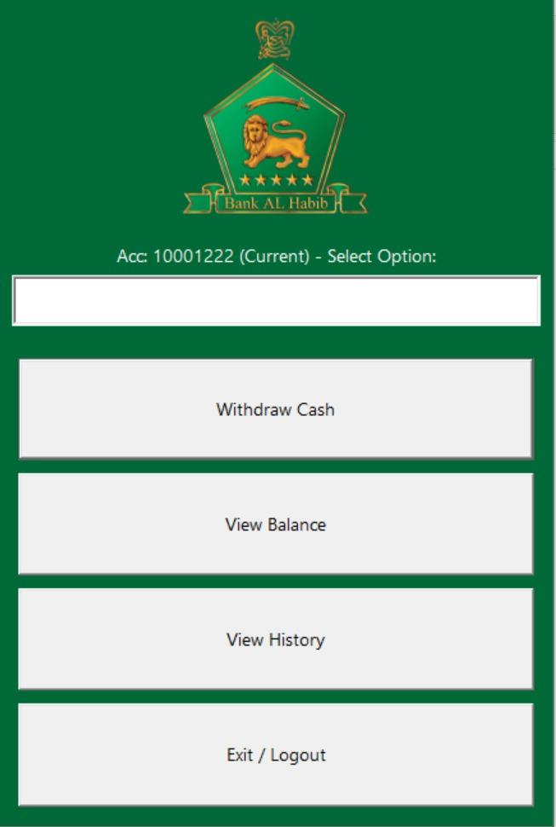

Data Analysis using Python:

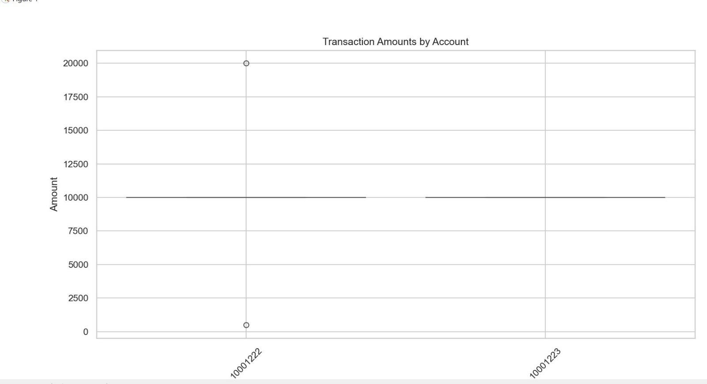

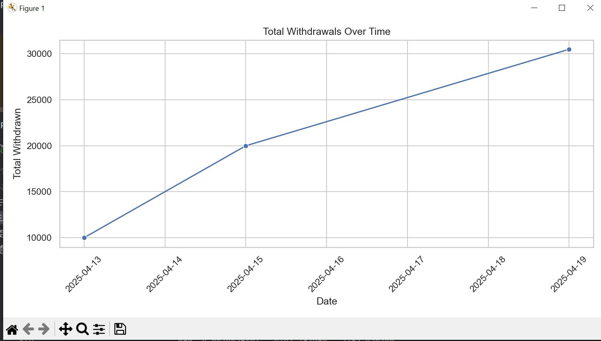

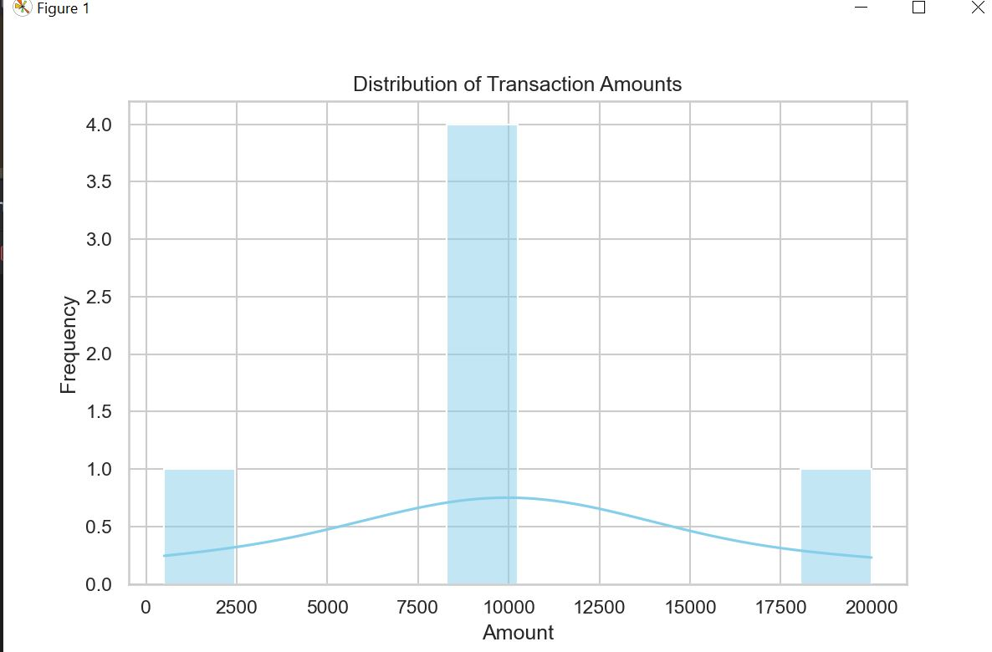

• Testing and Validation:

Tested on multiple systems and accounts to ensure accuracy of transactions and logs.

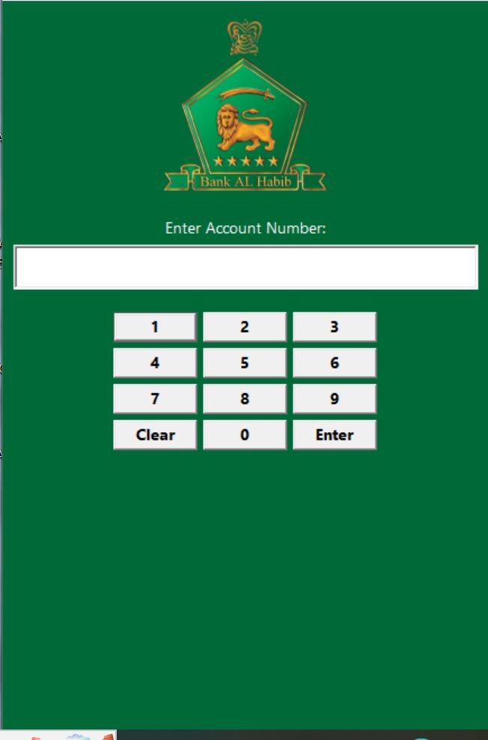

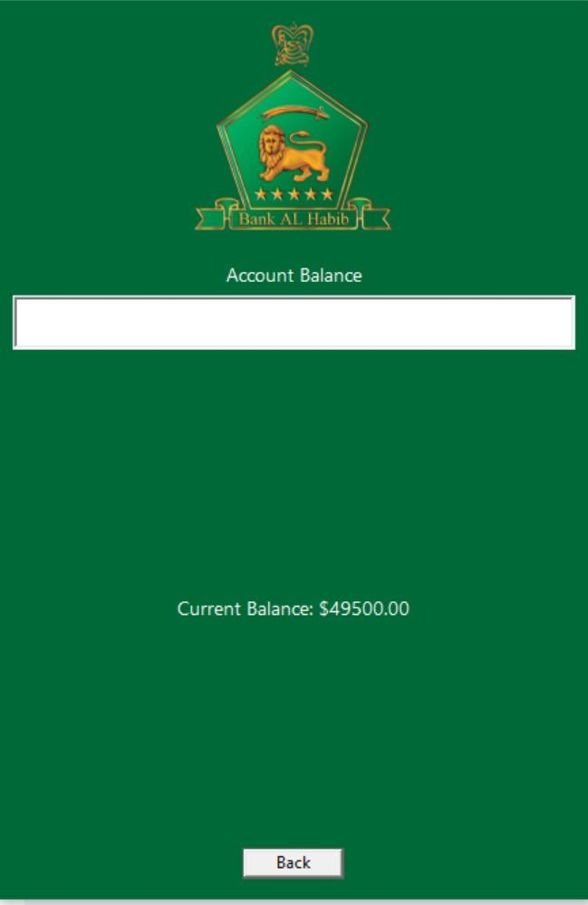

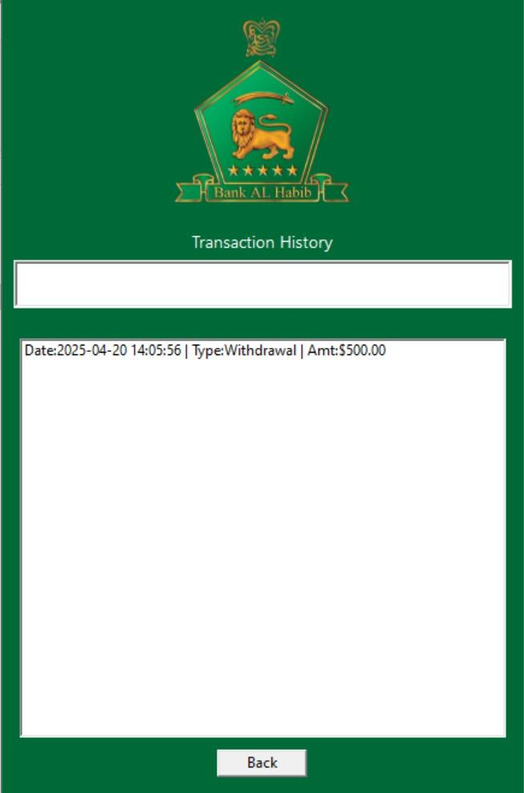

## 7. Conclusion

This project served as a comprehensive learning experience in applying Object-Oriented Programming (OOP) principles with GUI and data analysis. It provided exposure to integrating multiple components—C++ logic, a user-friendly interface, and Python-based analysis—to simulate a realistic ATM system.

The challenges faced, especially in linking the GUI with OOP structures and handling different development environments, significantly enhanced our problem-solving skills and technical adaptability.

Data analysis module using Python allowed us to gain learnings into data science and how data is managed. Transaction patterns were identified and displayed. Overall, the project allowed us to make a real world application and grasp the learnings of gui and data science which were completely new for us. We also learnt how classes and objects are used in systems to make it manageable and clear. Looking forward for making more projects ahead using concepts of OOP.